# Remote Health Monitoring for Critically ill patient

### Farhana Sultana

#### ID: 2013–2–60–046

**Maria Yasmin Nila**

**ID: 2013–2–60–047**

**Nahida Islam**

**ID: 2013–3–60–049**

**A thesis submitted in partial fulfillment of the requirements for the degree of Bachelor of Science in Computer Science and Engineering**



**Department of Computer Science and Engineering**

**East West University**

**Dhaka-1212, Bangladesh**

**December, 2017**

**Declaration**

We, hereby, declare that the work presented in this thesis is the outcome of the investigation performed by us under the supervision of name of your super visor , Professor, Department of Computer Science and engineering, East West University. We also declare that no part of this thesis/project has been or is being submitted elsewhere for the award of any degree or diploma.

Countersigned Signature

. . . . . . . . . . . . . . . . . . . . . . . . . . . . . . . . . . . . . . . . . . . . . . . .

## Dr. Ahmed Wasif Reza Farhana Sultana

#### Associate Professor & Chairperson ID: 2013-2-60-046

Department of Computer Science & Engineering

Signature

. . . . . . . . . . . . . . . . . . . . . . . .

##### Maria Yasmin Nila

ID: 2013-2-60-047

Signature

. . . . . . . . . . . . . . . . . . . . . . . .

##### Nahida Islam

ID: 2013-3-60-049

### 

### 

### Abstract

It’s our fundamental right to get quality Health Care. But now a day’s due to inadequate number of well qualified physician and vast number of population growth it has become very difficult to provide quality Health care services to everyone. So, in this paper we proposed a portable health care device that can be used as wearable or one can easily carry it with themselves that can be used to continuously monitor that patient’s bio status. Our proposed system monitors a patient’s oxygen saturation, blood pressure, blood glucose, body temperature and skin moisture and sends it to cloud. So that Patients with critical health condition can be remotely monitored by their preferred doctor from anywhere. In case of any emergency that doctor and hospital authority will be notified to prevent any loss of life.

### 

### Acknowledgements

As it is true for everyone, we have also arrived at this point of achieving a goal in our life through various interactions with and help from other people. However, written words are often elusive and harbor diverse interpretations even in one’s mother language. Therefore, we would not like to make eﬀorts to ﬁnd best words to express my thankfulness other than simply listing those people who have contributed to this thesis itself in an essential way. This work was carried out in the Department of Computer Science and Engineering at East West University, Bangladesh.

First, we would like to express my deepest gratitude to the Almighty for His blessings on us. Next, our special thanks go to our supervisor, “Dr. Ahmed Wasif Reza”, who gave us this opportunity, initiated us into the ﬁeld of “Remote Health Monitoring for Critically Ill Patient”, and without whom this work would not have been possible. His encouragements, visionaries and thoughtful comments and suggestions, unforgettable support at every stage of our B.Sc. study were simply appreciating and essential. His ability to muddle us enough to ﬁnally answer our own question correctly is something valuable what We have learned, and We would try to emulate, if ever We get the opportunity.

We would like to thank “Our own team” for excellent collaboration during performance evaluation studies; and our special thanks to “Dr. Salah Uddin” Sir for his overall support and helpful suggestions in solving tricky technical problems. Last but not the least, we would like to thank our parents for their unending support, encouragement and prayers.

Acknowledgements

There are numerous other people too who have shown me their constant support and friendship in various ways, directly or indirectly related to our academic life. We will remember them in our heart and hope to ﬁnd a more appropriate place to acknowledge them in the future.

Farhana Sultana

December 2017

Maria Yasmin Nila

December 2017

Nahida Islam

December 2017

**Table of Contents**

Chapter 1 6

1.1 IOT in Healthcare 7

1.2 Motivation 7

1.3 Problem statement 8

1.4 Objectives 8

1.5 Thesis Organization 9

Chapter 2 10

2.1 Overview of Arduino 10

2.1.1 Arduino Uno 11

2.1.2 Features of the Arduino UNO 12

2.1.3 Arduino Power 13

2.1.4 Arduino Power PINS 13

2.1.5 Arduino Memory 14

2.1.6 Arduino input and output 14

2.1.7 Arduino LEDs 16

2.2 Ethernet Shield 17

2.2.1 Ethernet Shield Features 18

2.2.2 Ethernet Shield LEDs 18

2.3 W5100 Datasheet 19

2.3.1 Target Application for W5100 20

2.3.2 W5100 Features 21

2.3.3 W5100 Memory Mapping 22

2.4 Pulse Sensor Max30100 23

2.4.1 Pulse Sensor Max30100 Key Features 23

2.5 PAM8403 2 Channel USB Power Audio Amplifier Module Board 3Wx2 Volume Control 24

2.6 ACS712-30A Current Sensor Module 25

2.6.1 Specifications 25

2.7 Humidity Sensor 26

2.8 Survey of existing technique 27

Chapter 3 29

3.1 IoT Healthcare Applications 29

3.1.1 Glucose Level Sensing 29

3.1.2 Blood Pressure Monitoring 30

3.1.3 Body Temperature Monitoring 30

3.1.4 Oxygen Saturation Monitoring 30

3.2 Decisions of design specification and hardware 30

3.3 Hardware Connection 31

3.3.1 Max30100 pulse sensor: 32

3.3.2 Oxygen Saturation 37

3.3.3 Working Procedure of Moisture Sensor 38

3.3.4 Working Procedure of Moisture Sensor 38

3.3.5 Glucometer 39

3.4 Circuit Diagram 43

3.5 Project Flow Chart 44

Chapter 4 46

4.1 Circuit connection 46

4.2 Real time monitoring 48

4.3 IoT Platforms and Data Security 50

Chapter 5 52

5.1 Overall Conclusion 52

5.2 Future Work 53

Bibliography 54

**List of Figures**

Figure 1‑1: IoT in Health Care 7

Figure 2‑1: Arduino Uno 11

Figure 2‑2:Components of Arduino 12

Figure 2‑3:Arduino Schematic I/O pins 14

Figure 2‑4: ATmega 328 16

Figure 2‑5: Ethernet Shield 17

Figure 2‑6: Schematic diagram of Ethernet shield 19

Figure 2-7: W5100 Block Diagram 20

Figure 2‑8: W5100 Pin Description 21

Figure 2‑9: W5100 Pin Diagram 22

Figure 2‑10: W5100 Memory Mapping 22

Figure 2‑11 : Max30100 23

Figure 2‑12: PAM8403 Audio Amplifier 24

Figure 2‑13: Current Sensor 25

Figure 2‑14: Humidity Sensor 26

Figure 3‑1: Block Diagram of the System 31

Figure 3‑2: Max30100 with Arduino 33

Figure 3-3: Master Slave Communication I2C 34

Figure 3-4: Clock and Data Packets 35

Figure 3-5: Serial Communication between two Devices 36

Figure 3-6: Serial Data Packets 37

Figure 3-7: Moisture Sensor with Arduino 39

Figure 3-8: Glucometer Principle 40

Figure 3-9: Glucometer Arduino 42

Figure 3-10: Circuit diagram of full system. 43

Figure 3-11: Flow Chart for the complete design methodology of Sensor 44

Figure 3-12: Flow Chart for the complete design methodology of Server 45

Figure 4-1: Actual Picture of The Embedded System 46

Figure 4-2: Embedded System 47

Figure 4-3: Web Interface 48

Figure 4‑4: Mobile Application 49

**List of Tables**

Table 1:Features of Arduino Uno 13

# Chapter 1

***Introduction***

**Internet of Things(IOT)**

Web of things(IOT) is a cover arranging system which is used to send data or information through any contraption to a split and a specific essential authority process or count is associated with control any device in perspective of that data or information. Tolerant observing framework is a true use of IOT. In the framework every one of the gadgets or question are interconnected through a system and they utilize thermometer, pulse sensor, sugar level check and so on to gather quiet legitimate temperature, blood weight and so forth and demonstrate this data to their individual doctors. For illustration if a client isn't registered, he/she should must be registered. After getting enlisted, he/she can utilize the administrations gave by the system. As the patient is utilizing the framework specialist can see their present and past record. If the specialist isn't checking and understanding condition is terrible which is appeared in the record then a notice goes to their doctor, as an outcome specialist can make quick move with respect to the state of patient.

## **IOT in Healthcare**

There are a few advantages to utilizing IoT in human services, running from enhancing system network to supporting remote patient checking and telemedicine. After quite a long time, IoT keeps on demonstrating its incentive in medicinal services. Regardless of whether inside clinic offices or patients'... homes, the utilization of IoT in medicinal services bolsters activities that positively affect operations and patient care. Subsequently, IT pioneers are quickening their assessment and appropriation of IoT, and rapidly distinguishing territories that make associated gadgets important and key parts of its innovation guide. Both IT and clinical experts are amped up for the utilization of IoT in medicinal services and the open doors it conveys to the table. The commercial center offers many associated gadgets to browse that can screen patients' vitals progressively and give alarms or input on their condition. This kind of information enhances quiet results.

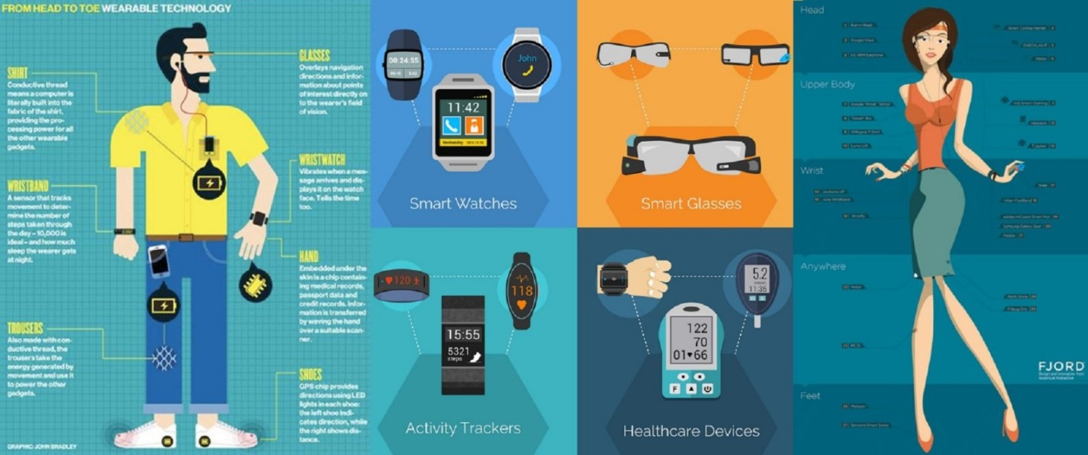

Figure 1‑1: IoT in Health Care

## **Motivation**

The quantity of patient we have a place in our nation that number of restorative administrations we don't have really. Because of the absence of specialist administrations, stick out and about and so on we require prompt watch over patient which can spare their live. some of the time a patient condition is basic or he/she isn't in a position to go to medicinal place for check up their blood pressure, temperature measure, check sugar level and so forth it might be take some to go their where in our nation street condition and circumstance isn't so good.by getting this every therapeutic administration each time is very costly for patient.so in our framework a patient can get this administrations from their home.in the framework tolerant information go to the cloud through IOT and their specialist can screen them. If persistent condition is terrible than a notice goes to their doctor.so specialist can make their move.

## **Problem statement**

In our nation individuals don't get quality social insurance because of the absence of qualified doctor and tremendous number of populace growth. Due to the condition in the correspondence on roadside basically sick patient can't ready to concede on healing center get legitimate service. In a most noticeably awful situation persistent is dead. Sometimes quiet past entire therapeutic history isn't there in specialist medicinal record, as an outcome specialist can't give appropriate treatment. And on the off chance that they surrender it isn't to the stamp for understanding for be completely cured. For illustration a diabetes or heart tolerant must be screen time to time because whenever awful may be happen. Another issue is that patient data is going to specialist’s restorative history however specialist is uninformed of his or her patient basic position. In this conditions patient might be dead. For a fundamentally sick patient it is very hard to go to the doctor's facility get checked the blood pressure, blood glucose, human moister etc., as this gadget isn't wearable.

## **Objectives**

1. To develop an effective wearable device based on medical service for the patient
2. To monitor patient’s current health condition

## **Thesis Organization**

The layout of rest of this report has been organized as takes after.

**Chapter 2** presents the literature review on the topic of patient monitoring system and IoT.

**Chapter 3** explains methodology of the project that how the project being implemented.

**Chapter 4** presents the real implementation of the project.

**Chapter 5** outlines conclusion of this work precisely and describes the scope of future work for possible extended application of the project.

# Chapter 2

***Literature Review***

**Hardware Reference**

Here, we depict the whole inserted arrangement of our venture where all the fundamental parts name, their hugeness in the undertaking are portrayed intricately.

## **Overview of Arduino**

Arduino is an open-source device organize in perspective of easy to-use gear and programming. Arduino sheets can read inputs-light on a sensor, a finger on a catch, or a twitter message - and change it into a yield instituting an engine, turning on a LED, distributing something on the web. you can direct your board by sending a plan of rules to the microcontroller on the board.to do all things considered you use the Arduino programming dialect (in perspective of wiring), also, the Arduino Software(IDE), considering preparing. During the time Arduino has been the cerebrum of thousands of activities, from normal articles to complex sensible instruments.an general gathering of makers - understudies, specialists, craftsmen, developers and specialists - has aggregated around this open-source stage, their duties have meant an awe-inspiring measure of accessible data that can be of remarkable help to students and masters alike. all Arduino sheets are absolutely open-source, connecting with customers to gather them self-governing and over the long haul alter them to their needs. The product, as well, is open-source, and it is getting to be noticeably through the duties of customers around the world.in our proposed work, we have used Arduino Uno.

### Arduino Uno

Arduino Uno is a microcontroller board in perspective of the ATmega328P (datasheet). It has 14 modernized information/yield pins (of which 6 can be used as PWM yields), 6 straightforward data sources, a 16 MHz quartz crystal, a USB affiliation, a power jack, an ICSP header and a reset get. It contains everything anticipated that would help the microcontroller; just interface it to a PC with a USB connection or power it with an AC-to-DC connector or battery to start.

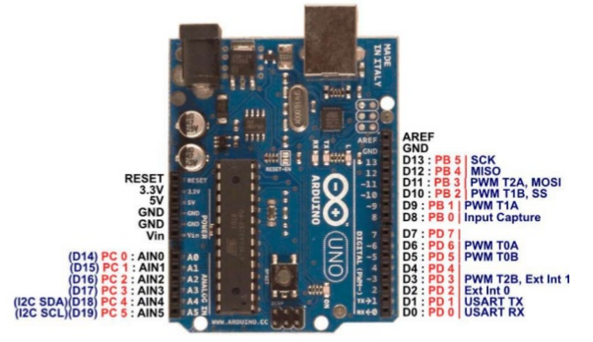

Figure 2‑1: Arduino Uno

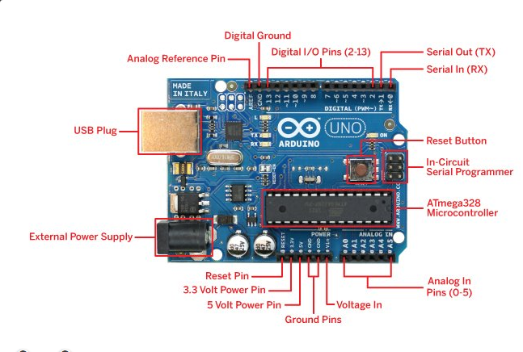

Figure 2‑2:Components of Arduino

### Features of the Arduino UNO

|  |  |
| --- | --- |
| Microcontroller | [ATmega328P](http://www.atmel.com/Images/Atmel-42735-8-bit-AVR-Microcontroller-ATmega328-328P_Datasheet.pdf) |
| Operating Voltage | 5V |
| Input Voltage  (recommended) | 7-12V |
| Input Voltage (limit) | 6-20V |
| Digital I/O Pins | 14 (of which 6 provide PWM output) |
| PWM Digital I/O Pins | 6 |
| Analog Input Pins | 6 |
| DC Current per I/O Pin | 20 mA |
| DC Current for 3.3V Pin | 50 mA |
| Flash Memory | 32 KB (ATmega328P) of which 0.5 KB used by bootloader |
| SRAM | 2 KB (ATmega328P) |
| EEPROM | 1 KB (ATmega328P) |
| Clock Speed | 16 MHz |

*Table 1:Features of Arduino Uno*

### Arduino Power

The Arduino Uno can be fueled by means of the USB association or with an outer power supply. The control source is chosen automatically. External (non-USB) power can come either from an AC-to-DC adapter (wall-wart) or battery. The connector can be associated by connecting a 2.1mm center _positive attachment to the board's energy jack. Leads from a battery can be embedded in the GND and VIN stick headers of the POWER connector. The board can work on an outside supply of 6 to 20 volts. If provided with under 7V, however, the 5V stick may supply under five volts and the board might be unstable. If utilizing more than 12V, the voltage controller may overheat and harm the board. The prescribed range is 5 to 12 volts.

### Arduino Power PINS

**VIN** : The information voltage to the Arduino board when it's utilizing an outer power source (as contradicted to 5 volts from the USB association or another controlled power source). You can supply voltage through this pin, or if providing voltage by means of the power jack, access it through this stick.

**5V** : The managed control supply used to control the microcontroller and different segments on the board. This can come either from VIN by means of an on-board regulator, or be provided by USB or another controlled 5V supply.

**3.3V** : A 3.3-volt supply produced by the on-board FTDI chip. Maximum current draw is 50 mA.

**GND** : Ground pins

### Arduino Memory

The ATmega 328 has 32 KB of flash memory for storing code (of which 0.5 KB is used for the bootloader), 2 KB of SRAM and 1 KB of EEPROM (which can be read and written with the EEPROM library).

### Arduino input and output

Looking at the board from the top down, this is an outline of what we will see

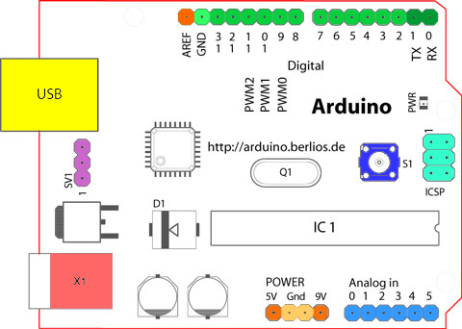

Figure 2‑3:Arduino Schematic I/O pins

#### *Starting clockwise from the top center*

* Analog Reference pin (orange)
* Digital Ground (light green)
* Digital Pins 2-13 (green)
* Digital Pins 0-1/Serial In/Out - TX/RX (dark green) - These pins cannot be used for digital I/O (**digital Read** and **digital Write**) if you are also using serial communication (e.g. **Serial. Begin**).
* Reset Button - S1 (dark blue)
* In-circuit Serial Programmer (blue-green)
* Analog in Pins 0-5 (light blue)
* Power and Ground Pins (power: orange, grounds: light orange)
* External Power Supply In (9-12VDC) - X1 (pink)
* Toggles External Power and USB Power (place jumper on two pins closest to desired supply) - SV1 (purple)
* USB (used for uploading sketches to the board and for serial communication between the board and the computer; can be used to power the board) (yellow).

Arduino Uno has 32 pins where 6 analog pins and 14 digital pins. Digital pins can be used as an input or output, using pin Mode (), digital Write () and digital Read () functions. They operate at 5 volts. Each pin can provide or receive a maximum of 40 mA and has an internal pull-up resistor (disconnected by default) of 20-50 K ohms. In addition, some pins have specialized functions:

PWM : 3, 5.6., 9-11 provide 8-bit PWM output with the analog Write () functions.

SPI :10 (SS), 11 (MOSI), 12 (MISO), 13 (SCK). These pins bolster SPI correspondence, which although gave by the basic equipment, isn't right now incorporated into the Arduino dialect. The SPI pins are additionally broken out on the ICSP header.

External Interrupts : 2 (interrupt 0), 3 (interrupt 1). These pins can be designed to trigger a hinder on a low esteem, a rising or falling edge, or an adjustment in esteem.

A4 (SDA) & A5 (SCL): Support TWI communication utilizing the wire library (documentation on the wiring site).

LED13 : There is a worked in Driven associated with computerized stick 13. at the point when the stick is HIGH esteem, the Drove is on, when the stick is LOW, it's off.

Serial : 0 (RX) and 1 (TX). Used to get (Rx) and transmit (TX) TTL serial information. Pins 0 and 1 are additionally associated with the comparing pins of the FTDI USB-to-TTL Serial chip.

Uno has 6 analog inputs, each of which provides 10 bits of resolution (1024 different values). By default, they measure from ground to 5 volts, through is it possible to change the upper end of their range using the AREF pin and analog Reference () function.

There are a couple of other pins on the board:

AREF : The reference voltage for the analog inputs. Used with analog Reference ().

Reset : Used to get (Rx) and transmit (TX) TTL serial information. Pins 0 and 1 are additionally associated with the comparing pins of the FTDI USB-to-TTL Serial chip.

### Arduino LEDs

In like manner, the Arduino has four LEDs: L, RX, and TX and ON. On the mega, ON stick is on the base right, L, TX, RX is on the Upper Right corner of Arduino Uno.

ON LED : This LED will sparkle green at whatever point the Arduino is fueled. Continuously check this LED if your Arduino isn't acting right, if it's gleaming or off then you should check your energy supply.

RX and TX LED : These resemble 'send' and 'get' LEDs on your link modem. They flicker whenever data is sent from or not to the Arduino through the USB association. The TX LED illuminates yellow at whatever point information is sent from the Arduino to the PC USB port. The RX LED illuminates yellow at whatever point information is sent to the Arduino from the PC USB port.

L LED : This is the one LED that you can control. the ON, RX and TX LEDs all light up naturally regardless of what, the L Drove, be that as it may, is associated with the Arduino principle chip and you can turn it on or off when you begin composing code and transferring on it.

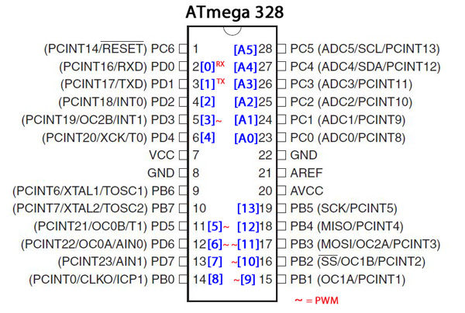

Figure 2‑4: ATmega 328

## **Ethernet Shield**

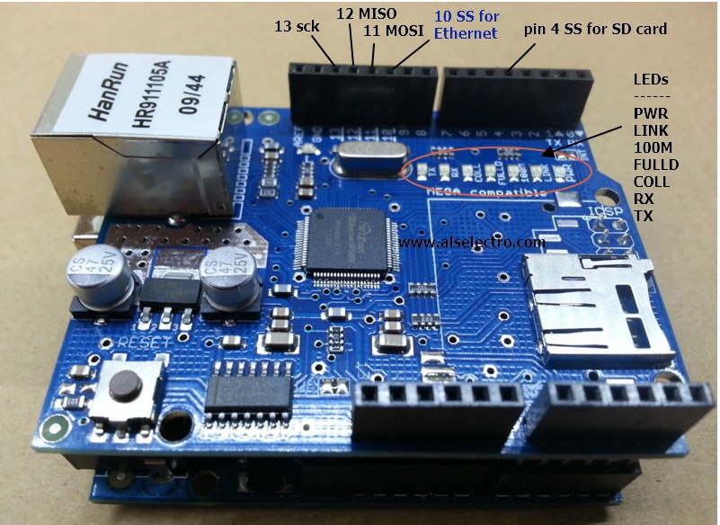

Figure 2‑5: Ethernet Shield

The Arduino Ethernet Shield permits an Arduino board to interface with the internet. It depends on the Wiznet-W5100 Ethernet chip. The Wiznet-W5100 gives a network (IP) stack equipped for both TCP and UDP. It bolsters up to four simultaneous attachment connections. Use the Ethernet library to compose draws which associate with the web utilizing the shield. The Ethernet shield interfaces with an Arduino board utilizing long wire-wrap headers which reach out through the shield. This keeps the stick design intact and enables another shield to be stacked to finish everything. The most recent update of the shield includes a miniaturized scale SD card slot, which can be utilized to store documents for serving over the network. It is good with the Arduino Duemilanova and Mega (utilizing the Ethernet library coming in Arduino 0019). An SD card library isn't yet incorporated into the standard Arduino distribution. The most recent correction of the shield likewise incorporates a reset controller, to guarantee that the W5100 Ethernet module is appropriately reset on control up. The first update of the shield contained a full-measure SD card slot; this isn't supported. Arduino speaks with both the W5100 and SD card utilizing the SPI transport (through the ICSP header). On both boards, pin 10 is utilized to choose the W5100 and 4 for the SD card. These pins can't be utilized for general I/O, but it must be kept as a yield or the SPI interface won't work. Note that because the W5100 and SD card shares the SPI bus, only one can be dynamic at a time. If you are utilizing the two peripherals in our program. This ought to be dealt with by the relating libraries. If we are utilizing the two peripherals in our program, this ought to be dealt with by the comparing libraries. If we are not utilizing one of the peripherals in our program, however, we need to expressly deselect it. To do this with the SD card, set stick 4 as a yield and compose a high to it. To the W5100, set advanced stick 10 as a high output. The shield gives a standard RJ45 Ethernet jack. The reset catches on the shield resets both the W5100 and the Arduino board.

### Ethernet Shield Features

ATMega328 Microcontroller.

Operating Voltage : 5V.

Input Voltage : 7-12V.

Digital I/O pins : 14 (4 of which are used by the Ethernet controller).

Analog Input pins : 6.

On Board Micro SD Card slot.

W5100 TCP/IP Embedded Ethernet Controller.

### Ethernet Shield LEDs

**PWR** : Demonstrates that the board and shield are controlled.

**LINK** : Shows the nearness of a system connection and flashes when the shield transmits or gets information

**FULL D** : Demonstrates that the system association is full duplex.

**100M** : Shows the nearness of a 100Mb/s arrange association (instead of 10 Mb/s).

**RX** : Flashes when the shield gets information

**TX**  : Flashes when the shield sends information

**COLL** : Flashes when organize impacts are identified.

The patch jumper stamped "INT" can be associated with permit the Arduino board to get intrude driven notice of occasions from the w5100, but this isn't bolstered by the Ethernet library. The jumper interfaces the INT stick of the W5100 to computerized stick 2 of the Arduino.

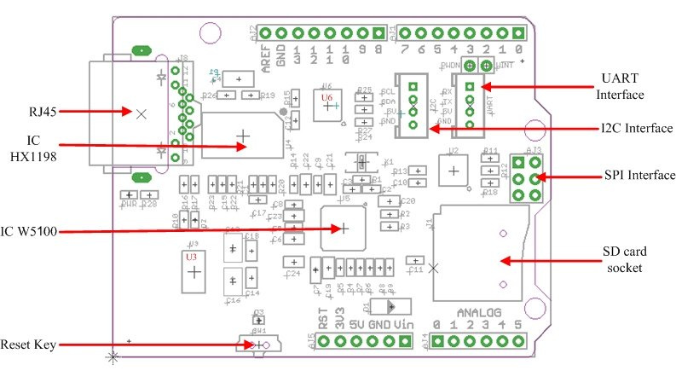

Figure 2‑6: Schematic diagram of Ethernet shield

## **W5100 Datasheet**

The W5100 is a full-included, single-chip web empowered 10/100 Ethernet controller intended for installed applications where simplicity of integration, stability, performance, area and framework cost control are required. The W5100 has been intended to the ciliate simple execution of web availability without OS. The W5100 is IEEE 802.3 10BASE-T and 802.3u 100BASE-TX agreeable.

The W5100 incorporates completely hardwired, market-demonstrated TCP/IP stack and coordinated Ethernet MAC and PHY. Hardwired TCP/IP stack underpins TCP, which has been demonstrated in different applications for a few years.16Kbytes inner cradle is incorporated for information transmission.no need of thought for dealing with Ethernet controller, yet basic attachment writing computer programs is required. For simple integration, three diverse interfaces like memory get to way, called coordinate transport and SPI, are upheld on the MCU side.

### Target Application for W5100

The W5100 is appropriate for some inserted application, including

Home Network Devices: Set-Top Boxes, PVRs, Digital Media Adapters

Security Systems : DVRs, Network Cameras, Kiosks

Serial-to-Ethernet : Access Controls, LED displays, Wireless AP relays, etc.

Parallel-to-Ethernet : POS/ Mini Printers, Copiers

USB-to-Ethernet : Storage Devices, Network Printers

GPIO-to-Ethernet : Home Network Sensors

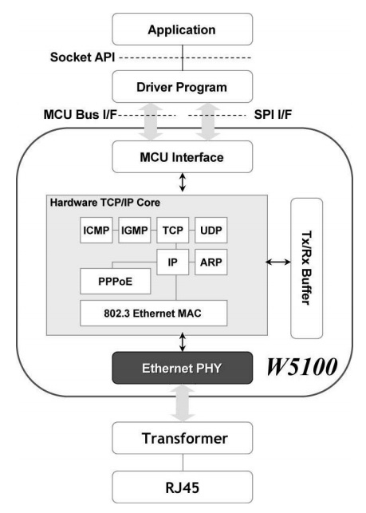

Figure 2-7: W5100 Block Diagram

### W5100 Features

* Support Hardwired TCP/IP Protocols: TCP, UDP, IPv4, ICMP, ARP, IGMP, PPPoE Ethernet
* 10BaseT/100BaseTX Ethernet PHY embedded
* Support Auto Negotiation (Full-Duplex and half-duplex)
* Support auto MDI/MDIX
* Support ADSL connection (with support PPPoE Protocol with PAP/CHAP Authentication mode)
* Support 4 independent sockets simultaneously
* Not supported IP Fragmentation
* Internal 16Kbytes Memory for TX/RX Buffers
* 0.18 micro m CMOS technology
* 3.3V operation with 5V I/O signal tolerance
* Small 80 pin LQFP Package
* Lead-Free Package
* Support Serial Peripheral Interface (SPI MODE 0. 3)
* Multi-function LED outputs (TX, RX, Full/Half duplex, Collision, Link, speed)

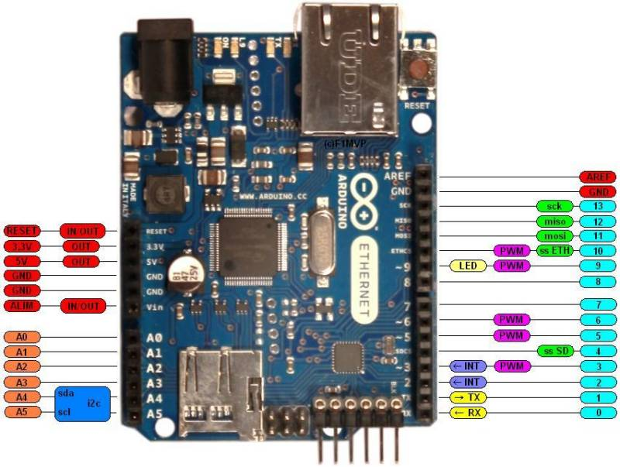

Figure 2‑8: W5100 Pin Description

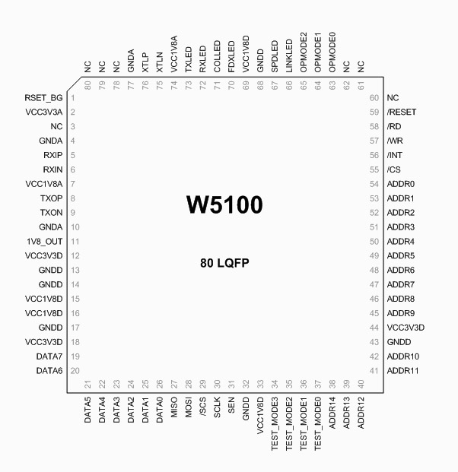

Figure 2‑9: W5100 Pin Diagram

### W5100 Memory Mapping

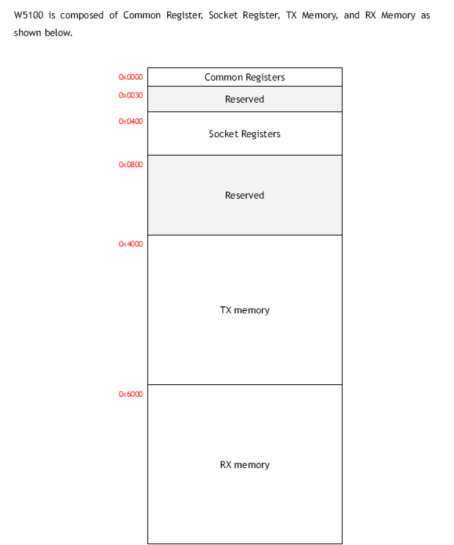

Figure 2‑10: W5100 Memory Mapping

## **Pulse Sensor Max30100**

The MAX30100 is an incorporated heartbeat oximetry and heart-rate screen sensor arrangement. It consolidates two LEDs, a photodetector, improved optics, and low-clamor simple flag preparing to recognize beat oximetry and heart-rate signals.

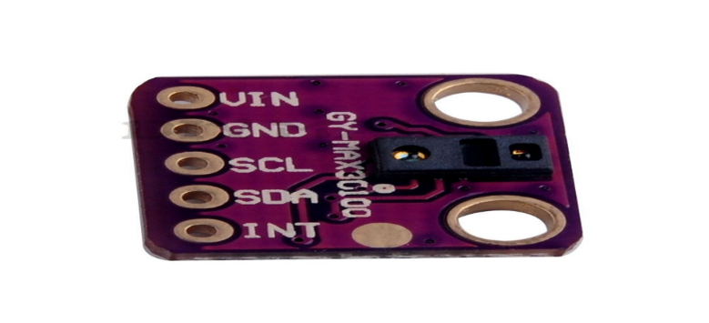

Figure 2‑11 : Max30100

The MAX30100 works from 1.8V and 3.3V power supplies and can be shut down through programming with irrelevant standby current, allowing the power supply to stay associated consistently.

### Pulse Sensor Max30100 Key Features

* Complete Pulse Oximeter and Heart-Rate Sensor Solution Simplifies Design
  + Integrated LEDs, Photo Sensor, and High-Performance Analog Front-End
  + Tiny 5.6mm x 2.8mm x 1.2mm 14-Pin Optically Enhanced System-in-Package
* Ultra-Low-Power Operation Increases Battery Life for Wearable Devices
  + Programmable Sample Rate and LED Current for Power Savings
  + Ultra-Low Shutdown Current (0.7µA, type)
* Advanced Functionality Improves Measurement Performance
  + High SNR Provides Robust Motion Artifact Resilience
  + Integrated Ambient Light Cancellation
  + High Sample Rate Capability
  + Fast Data Output Capability

1. **PAM8403 2 Channel USB Power Audio Amplifier Module Board 3Wx2 Volume Control**

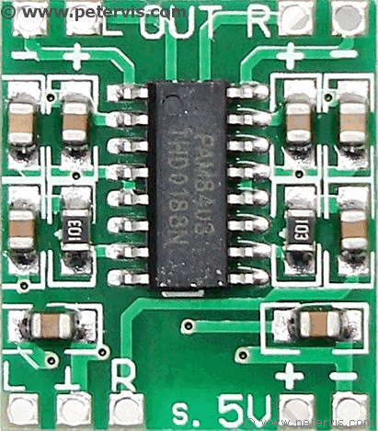

Figure 2‑12: PAM8403 Audio Amplifier

### 2.5.1 Features

* Operating voltage: 2.5V-5.5V
* Maximum output power: 3W*2(5V 4Ω)
* Length: 29mm
* Width: 20mm
* Overall height after installed is about 16mm.

## **ACS712-30A Current Sensor Module**

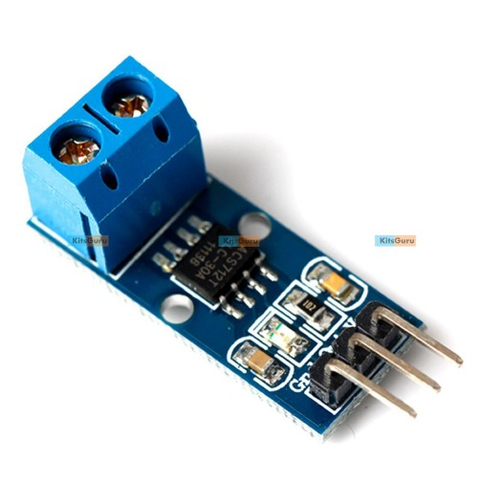

Figure 2‑13: Current Sensor

### Specifications

##### The current sensor chips: acs712elc-20a;

##### Pin 5 V power supply on board power indicator;

##### The module can measure the positive and negative 20 amps, corresponding to the analog output of 100mv / a;

##### No test current through the output voltage is VCC / 2;

##### PCB board size: 31 (mm) x13 (mm);

##### Note: ACS712 is based on the principle of the Hall test, please use this field to avoid impact

## **Humidity Sensor**

Humidity Sensor is a straightforward breakout for measuring the dampness in soil and comparative materials. The dirt dampness sensor is straight forward to utilize. The two substantial uncovered cushions work as tests for the sensor, together going about as a variable resistor. The more water that is in the dirt means the better the conductivity between the cushions will be and will bring about a lower protection, and a higher SIG out.

To get the Humidity Sensor working all you will require is to interface the VCC and GND pins to your Arduino-based gadget (or perfect improvement board) and you will get a SIG out which will rely upon the measure of water in the dirt. One ordinarily known issue with soil dampness sensors is their short life expectancy when presented to a sodden situation. To battle this, we've had the PCB covered in Gold Finishing (ENIG or Electro Less Nickel Immersion Gold). We prescribe either a straightforward 3-stick screw stick terminal or a 3-stick jumper wire gathering (both can be found in the Recommended Products segment beneath) to be patched onto the sensor for simple wiring.

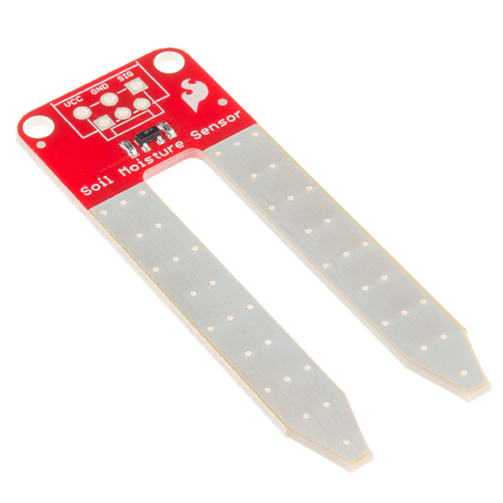

Figure 2‑14: Humidity Sensor

## **Survey of existing technique**

The surveys from various papers are taken and considered. A some of them are given below:

The paper at [1] IOT innovation is executed in various medicinal parameters to advance Human services specialized strategy. During earlier times of patient health evaluation, doctors or physicians need to physically check the patients’ health behavior & too frequently monitor them. This along these lines prompts the circumstance of disorder and confusion while managing the substantial number of patients at Once. Now the childhood of IOT totally changed this example. With the assistance of fuse of different sensors (temperature, oximeter), PIC 18F46K22 MICROCONTROLLER is incorporated to give a typical passage of correspondence among sensors. Different security highlights are likewise reveled with this venture, including the AES128 bit encryption over information transmission through secret word ensured Wi-Fi module ESP8266. The system can effectively execute with low power utilization capacity, simple to setup, elite and time to time reaction workplace.

The paper at [2] is mainly focused on continuous monitoring aspect of home patients & helps doctors to monitor patient health parameters easily (temperature, heart rate, pulse rate, glucose, etc.) by detecting it, processing it, & sending this data over a wireless. This helps to take care of critically ill patients to save their lives in almost every hospital in the ICUs.

The paper at [3] incorporates the data about how to construct or build up another computational innovation considering clinical choice emotionally supportive networks, data preparing, remote correspondence and information mining kept new premises in the field of Personal Healthcare frameworks. This design is produced to accumulate and deal with an immense measure of information which supporting the doctors in their procedure of choice through a consistent comparative remote checking model. This design is helpful to assessing stress condition of individual subject ideal for stretch observing amid the time of typical exercises depicted. Some novel incorporated handling approach depend on the variables are autoregressive model; manufactured neural systems are useful for recognizing stress conditions. The engineering is intended to get the characterization terms of stress conditions.

The paper at [4] the estimation of remote correspondence advancements and giving a persistent remote help to patients and new instruments to build up the work process of the healing facility staff. This paper mostly speaks to the overview of remote correspondence innovations which are by and by connected in eHealth framework. The eHealth framework primary point is to give persistent and remote help to patients and well instruments to enhance the work process of healing facility faculty. The request of points of interest and disadvantages of present advancements likewise demonstrates the meaning of new research issues and conceivable outcome and answers for future eHealth frameworks.

# Chapter 3

***Design and Methodology***

# IoT Healthcare Applications

In addition to IoT services, IoT applications deserve closer attention. It can be noted that services are used to develop applications, whereas applications are directly used by users and patients. Therefore, services are developer-centric, whereas applications, user-centric. In addition to applications covered in this section, various gadgets, wearables, and other healthcare devices currently available in the market are discussed. These products can be viewed as IoT innovations that can lead to various healthcare solutions. The next subsections address various IoT-based healthcare applications, including both single- and clustered-condition applications.

### Glucose Level Sensing

With a blood glucose meter, you utilize blood to do the test though CGM is constant glucose observing. Consistent glucose checking isn't blood glucose observing as the sensors with a CGM machine are set into your body yet not into the circulation system. The sensors measure the glucose in your interstitial liquid - the liquid in and around your body's cells. The connection between glucose fixations in interstitial liquid (ISF) and blood has produced awesome enthusiasm because of the likelihood of picking up to 288 glucose level readings daily without doing finger pricks.

### Blood Pressure Monitoring

Most people utilize a programmed screen to quantify their pulse at home. These are additionally called electronic or computerized screens. They have a receiver to identify blood beating in the corridor. The sleeve wraps around your upper arm. It consequently blows up when you press the begin catch. This is the sort of circulatory strain screen regularly found in grocery stores, drugstores, and shopping centers.

### Body Temperature Monitoring

Temperature monitoring devices provide pertinent information that is required by healthcare professionals during a patient’s medical stay. These medical products offer comfortable and precise management of a patient’s stability, and are designed to be completely accurate and dependable to help regulate the healing process.

### Oxygen Saturation Monitoring

Oxygen saturation monitoring measures the amount of oxygen in your child's blood. It helps the nurses and doctors know if your child’s body is getting the oxygen it needs. It also tells them if your child's body is correctly using the oxygen your child is breathing.

## **Decisions of design specification and hardware**

Following diagram shows the complete transmitter and receiver flow.

Here four sensors are connected to Arduino Uno,

* MAX 30100 Pulse sensor which measures heart rate, Spo2 and temperature of patient’s body.
* Moisture Sensor which measures the moisture of patient’s body
* Glucometer measures the blood glucose of patient’s body.

These sensors are connected to Arduino Uno where all that information is processed and calculated. Then it is sent to WIFI/Ethernet module via Serial/SPI communication. Then data is transferred to Cloud. This stores real time data and provides accessibility for data.

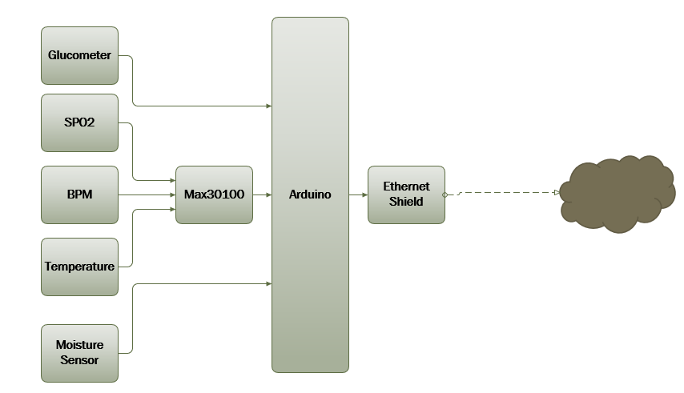

Figure 3‑1: Block Diagram of the System

## **Hardware Connection**

Here we are describing how each sensor in our system works. And how it is integrated into the full system.

### Max30100 pulse sensor:

The MAX30100 is an integrated pulse oximetry and heartrate Monitor sensor solution. It combines two LEDs, a Photodetector, optimized optics, and low-noise analog Signal processing to detect pulse oximetry and heart-rate Signals. The MAX30100 operates from 1.8V and 3.3V power supplies and can be powered down through software with Negligible standby current, permitting the power supply to Remain connected always.

A pulse oximeter is basically a device which can measure your pulse and oxygen saturation in Your blood. Usually this sensor consists of two LEDs emitting light: one in Red spectrum(650nm) and the other one in Infrared (950nm). This sensor is placed on your finger or Earlobe, essentially anywhere where the skin is not too thick so both light frequencies can Easily penetrate the tissue. Once both are shined through your finger for example, the absorption is measure with a photodiode. And depending on the amount of oxygen you Have in your blood the ratio between the absorbed red light and IR led will be different.

**Description of MAX30100**

First thing we must do, is to connect the sensor to our microcontroller and read its data. I won’t go in a lot of details; just some small notes and tips how it is done. Since I feel this is a Rather simple process.

First some important background about MAX30100:

* I2c address of MAX30100: 0x57
* Data is stored in a FIFO buffer. It can store up to 16 measurements, where each Sample is size of 4 bytes. First two bytes are for IR measurement and last two bytes Are for RED measurement.
* FIFO buffer can’t be read consequently with I2C, since the FIFO points to the same Address. You must finish transaction for FIFO output address to contain the next Values.
* MAX30100 has built in 50/60Hz filter
* If you want to just detect pulse, only IR is required
* For oxygen saturation you’ll need to enable both IR and RED LEDs
* By changing sampling rate and pulse width of the LEDs you also change the ADC Resolution. It is important to note that sample rate and pulse width are directly Linked to each other.

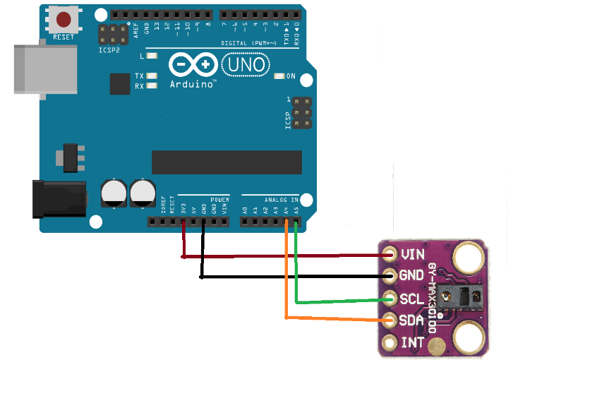

Figure 3‑2: Max30100 with Arduino

The I2C protocol is a very useful serial communication protocol. This popular system is used in a huge range of chips - just a few examples from this site include the DS1307 (RTC), SSD1306 (OLED Display), DS23017 (Serial expander). It allows you to connect many devices to a single set of two wires and then communicate individually with each device with which you can send and receive data.

'I2C' stands for Inter-Integrated Circuit and allows communication of data between I2C devices over two wires. It sends information serially using one line for data (SDA) and one for clock (SCL).

I2C shows us how the I2C protocol works at the physical bit level discussing single master mode (a single controlling device) which is the most common use for I2C in a small system.

#### *Master and slave*

The Philips I2C protocol defines the concept of master and slave devices. A master device is simply the device that oversees the bus now and this device controls the clock and generates START and STOP signals. Slaves simply listen to the bus and act on controls and data that they are sent.

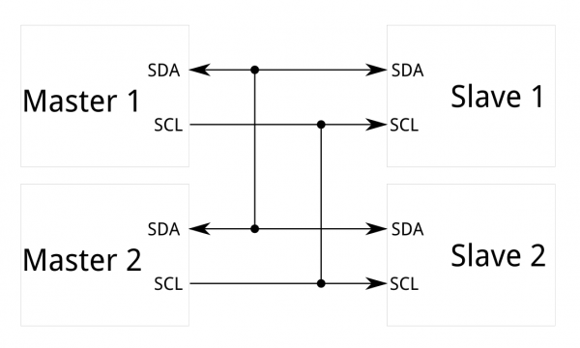

Figure 3-3: Master Slave Communication I2C

The master can send data to a slave or receive data from a slave - slaves do not transfer data between themselves.

#### *Data and Clock*

The I2C interface uses two bi-directional lines meaning that any device could drive either line. In a single master system, the master device drives the clock most of the time - the master oversees the clock, but slaves can influence it to slow it down If you use I2C you cannot put any other (non I2C) devices on the bus as both lines are used as clock at some point (generation of START and STOP bits toggles the data line). So, you cannot do something clever such as keeping the clock line inactive and use the data line as a button press detector (to save pins). You will often will find devices that you realize are I2C compatible, but they are labelled as using a '2 wire interface'. The manufacturer is avoiding paying royalties by not using the words 'I2C’! There are two wires (three if you include ground! and four if you also include power!) - But power and ground are taken as given i.e. they are available on a pcd as needed so don't really count.

Data Transfer from master to slave

I2C Tutorial: Instruction sequence data from master to slave

I2c tutorial master to slave

A master device sends the sequence S ADDR W and then waits for an acknowledge bit (A) from the slave which the slave will only generate if its internal address matches the value sent by the master. If this happens then the master sends DATA and waits for acknowledge (A) from the slave. The master completes the byte transfer by generating a stop bit (P) (or repeated start).

#### *Data transfer from slave to master*

I2C Tutorial: Instruction sequence data from slave to master, I2c tutorial slave to master

A similar process happens when a master reads from the slave but in this case, instead of W, R is sent. After the data is transmitted from the slave to the master the master sends the acknowledge (A). If instead the master does not want any more data, it must send a not-acknowledge which indicates to the slave that it should release the bus. This lets the master send the STOP or repeated START signal.

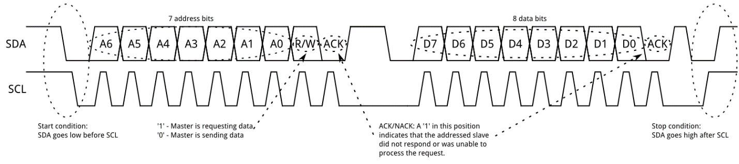

Figure 3-4: Clock and Data Packets

#### *Speed*

Standard clock speeds are 100 kHz and 10 kHz, but the standard lets you use clock speeds from zero to 100 kHz and a fast mode is also available (400 kHz - Fast-mode). An even higher speed (3.4MHz - High-speed mode) for more demanding applications - The mid-range PIC won't be up this mode yet!

The low-speed mode has been omitted (10 kHz) as the standard now specifies the basic system operating from 0 to 100 kHz.

Even if you run an I2C peripheral at a high speed the overall data rate depends on how fast you can push data into the internal I2C module and that depends on the processor speed.

A slow slave device may need to stop the bus while it gathers data or services an interrupt etc. It can do this while holding the clock line (SCL) low forcing the master into the wait state. The master must then wait until SCL is released before proceeding.

#### *Block diagram of an asynchronous serial system*

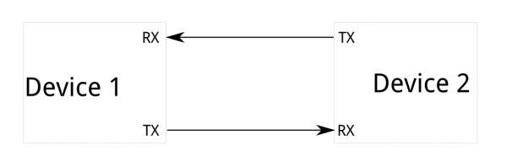

Figure 3-5: Serial Communication between two Devices

Because serial ports are asynchronous (no clock data is transmitted), devices using them must agree ahead of time on a data rate. The two devices must also have clocks that are close to the same rate, and will remain so–excessive differences between clock rates on either end will cause garbled data.

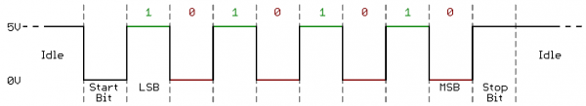

Figure 3-6: Serial Data Packets

Asynchronous serial ports require hardware overhead–the UART at either end is relatively complex and difficult to accurately implement in software if necessary. At least one start and stop bit is a part of each frame of data, meaning that 10 bits of transmission time are required for each 8 bits of data sent, which eats into the data rate.

Another core fault in asynchronous serial ports is that they are inherently suited to communications between two, and only two, devices. While it is possible to connect multiple devices to a single serial port, bus contention (where two devices attempt to drive the same line at the same time) is always an issue and must be dealt with carefully to prevent damage to the devices in question, usually through external hardware.

Finally, data rate is an issue. While there is no theoretical limit to asynchronous serial communications, most UART devices only support a certain set of fixed baud rates, and the highest of these is usually around 230400 bits per second.

### Oxygen Saturation

SpO2 stands for peripheral capillary oxygen saturation, an estimate of the amount of oxygen in the blood. More specifically, it is the percentage of oxygenated hemoglobin (hemoglobin containing oxygen) compared to the total amount of hemoglobin in the blood (oxygenated and non-oxygenated hemoglobin).

SpO2 is an estimate of arterial oxygen saturation, or SaO2, which refers to the amount of oxygenated hemoglobin in the blood. Hemoglobin is a protein that carries oxygen in the blood. It is found inside red blood cells and gives them their red color.

SpO2 can be measured by pulse oximetry, an indirect, non-invasive method (meaning it does not involve the introduction of instruments into the body). It works by emitting and then absorbing a light wave passing through blood vessels (or capillaries) in the fingertip. A variation of the light wave passing through the finger will give the value of the SpO2 measurement because the degree of oxygen saturation causes variations in the blood’s color. This value is represented by a percentage. If your Witlings Pulse OX says 98%, this means that each red blood cell is made up of 98% oxygenated and 2% non-oxygenated hemoglobin. Normal SpO2 values vary between 95 and 100%.

Good blood oxygenation is necessary to supply the energy your muscles need to function, which increases during a sports activity. If your SpO2 value is below 95%, that could be a sign of poor blood oxygenation, also called hypoxia.

You can easily measure your SpO2 with the Witlings Pulse Ox. We remind you that the Witlings Pulse Ox is not a medical device and must not be used to diagnose or monitor a pathological condition.

### Working Procedure of Moisture Sensor

Max30100 has different wavelength. It calculates light’s frequency. There's currently no code to get a temperature readout from the sensor. From the sensor it can sense the temperature.

### Working Procedure of Moisture Sensor

1. Power up humidity sensor by connecting VCC and GND.
2. Output pin goes to A0 pin of Arduino.
3. Temperature = ((value of analog pin 2) *.15)
4. repeat until value of humidity stops changing.

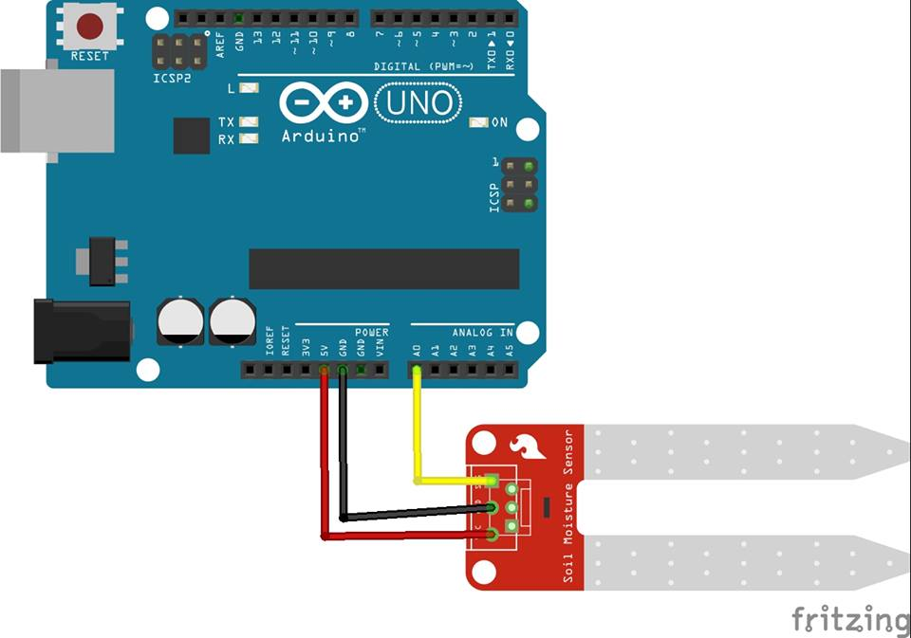

Figure 3-7: Moisture Sensor with Arduino

### Glucometer

A glucose meter is a therapeutic gadget used to decide the grouping of glucose in the solution. The glucose fixation is measured in units of milligram per deciliter (mg/dl) or millimole per liter (mmol/L) contingent upon the diverse districts. The glucose allot is a key component of home blood glucose checking (HBGM) gadget utilized by individuals with diabetes mellitus. The estimation can be taken various circumstances in a solitary day.

It decides the centralization of Glucose in the arrangement. This application notes centers on the outline of a glucose meter, including the Important equipment outline and programming Improvement.

Most glucose meters depend on electrochemical Innovation. They utilize electrochemical test strips to Play out the estimation. A little drop of the solution to be tried is set on a dispensable test strip that the Furthermore, the Amperometric technique.

In here we use amperometric method. Amperometric Method In this technique, the electrochemical test strip contains a Slim that is utilized to attract the arrangement set at One end of the test strip. The test strip likewise contains an Catalyst cathode containing a reagent, for example, Glucose Oxidase. Glucose experiences a compound Response within the sight of proteins and electrons are Delivered amid the substance response. These Electrons (i.e., the charge going through the Anode) are measured and this is corresponding to the Grouping of glucose in the arrangement. A surrounding Temperature estimation is likewise made with a specific end goal to Make up for the impact of temperature on the rate of the response the inserted glucose meters are electrochemical Also, utilize the Aerometric strategy.

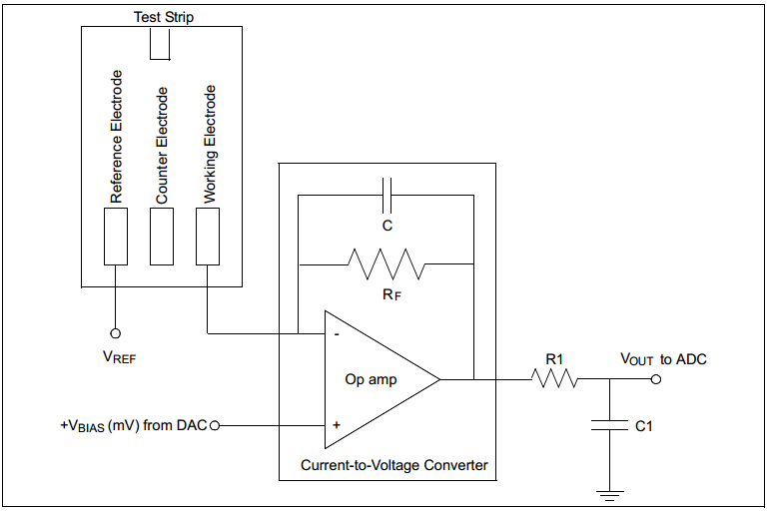

Figure 3-8: Glucometer Principle

The test strip frames the principle biochemical sensor where the specimen of arrangement is set. The test strip has the

#### *Following cathodes*

* Working cathode: Electrons are delivered here Amid the substance response. This cathode is associated with the current-to-voltage intensifier.
* Reference cathode: Held at a steady voltage Regarding the working cathode to push the Wanted compound responses.
* Counter cathode: Supplies current to the Working cathode.

A large portion of the glucose meter outlines utilize just two Cathodes, reference anode and working terminal. An exact reference voltage (VREF) is connected to the Reference anode and an exact inclination voltage (VBIAS) Is connected to the operation amp. Along these lines the exact potential Distinction is kept up over the working anode Furthermore, the reference anode. This voltage is the Jolt which drives the test strip's yield current. The arrangement test is put on the test strip and the Response of the glucose with the protein happens. Electrons are created amid the concoction response. Stream of electrons will compare to the stream of current Through the working and the reference cathode. This Current will change as indicated by the glucose Focus. The current is measured utilizing a Tran’s impedance intensifier (current-to-voltage Converter) for the estimation with an Analog-to Digital Converter (ADC). The yield of the Trans impedance enhancer will be a variety in the voltage with shifting glucose Fixations in the arrangement.

Test Strip  
+VBIAS (mV) from DACVREF

|  |
| --- |
| Working Electrode Reference Electrode Counter Electrode |
| RF C Current-to-Voltage Converter - + Op amp |

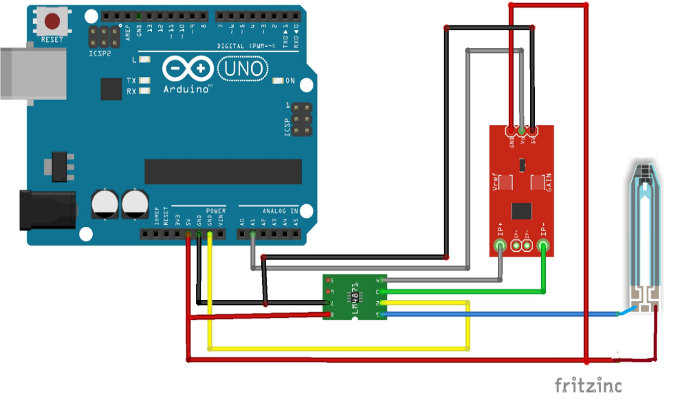

Figure 3-9: Glucometer Arduino

Here the following Figure 3-9 explains about the connection of Glucometer. The Glucometer is consisting of Current Sensor, Audio Amplifier and Arduino.

When we integrate all those sensors into our system it looks like this.

## **Circuit Diagram**

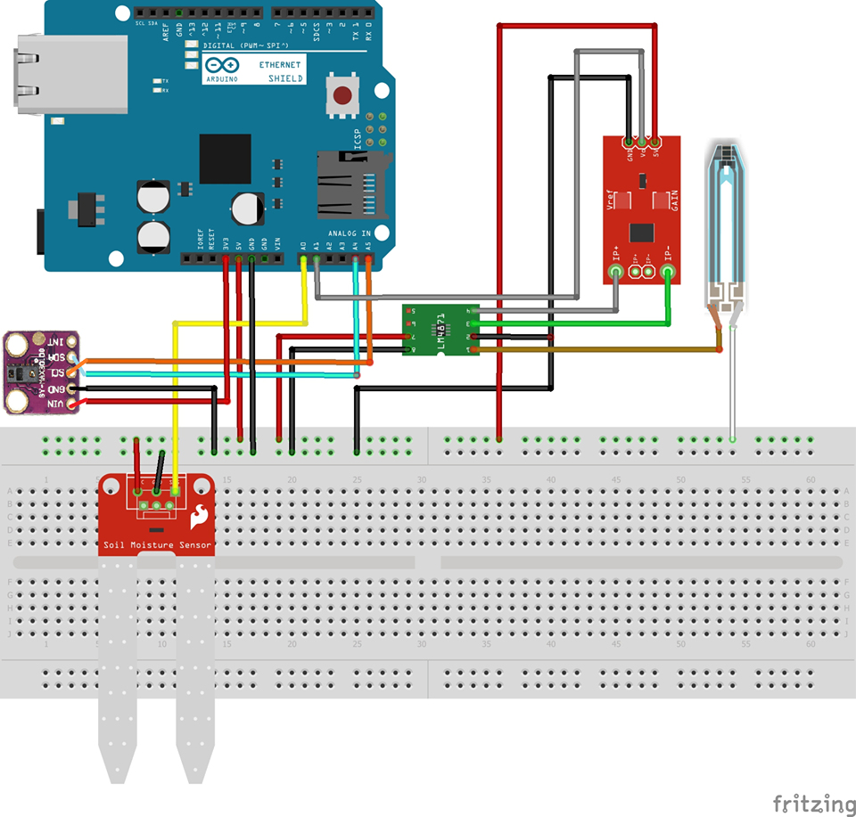

Figure 3-10: Circuit diagram of full system.

Figure 3-10 explain the Circuit Diagram of the embedded system. It also describes how the sensor is connect with Arduino. In our system we use Arduino Uno, Ethernet shield. Ethernet shield is installed on the top of Arduino Uno. Ethernet shield is used for sending data on the cloud. We use three sensors in our system. Among them we use Max30100 which is pulse oximeter. It is a digital sensor. it takes 3.3 volt and connected to the Arduino via IIC bus. beside this we use moisture sensor which is connected to the analogue pin of A0. The last sensor we used is glucometer. here we can see that the positive portion of strip relates to VCC and the other portion relates to the amplifier which amplifies the amount of current goes through the strip. The amplified current goes to the current sensor which converts current into voltage that can be read by analogue pin A21 of Arduino

## **Project Flow Chart**

The complete design flow of the project can be depicted by Figure

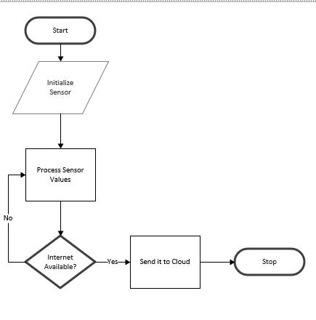

Figure 3-11: Flow Chart for the complete design methodology of Sensor

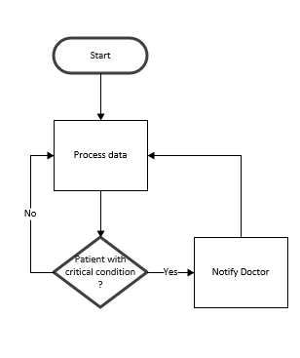

Figure 3-12: Flow Chart for the complete design methodology of Server

# Chapter 4

***Implementation***

**Embedded device**

## **Circuit connection**

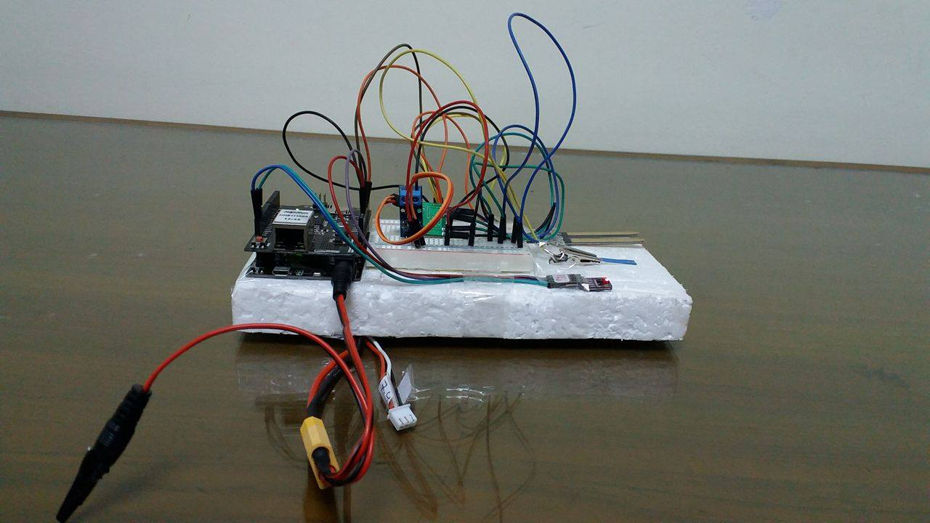

Figure 4-1: Actual Picture of The Embedded System

The project is developed by using Max30100, Humidity Sensor, Current Sensor directly connected to all the pins of Arduino. Pin A0 is used for connecting output of humidity sensor of Arduino as A1 is for Glucometer.

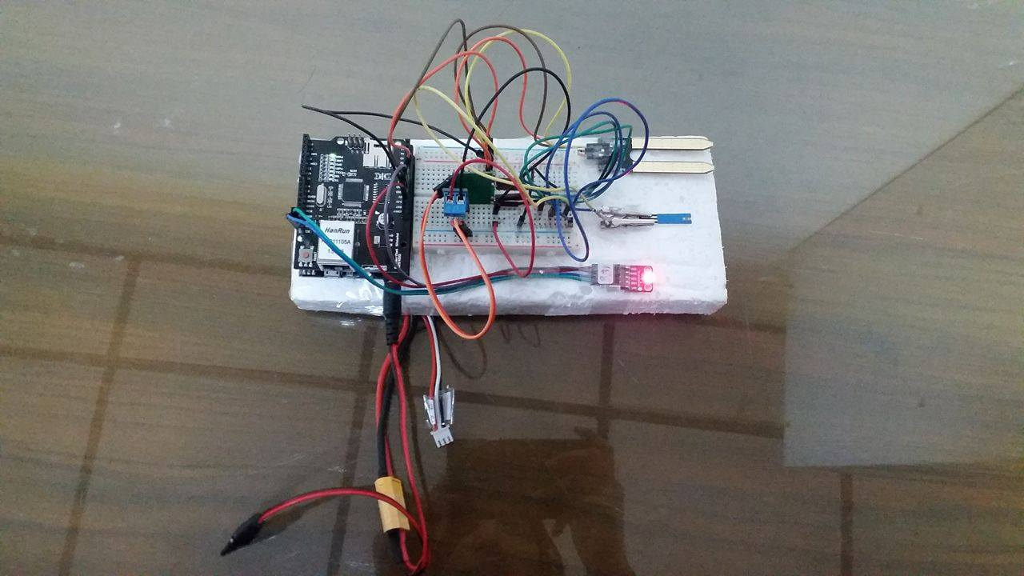

Figure 4-2: Embedded System

## **Real time monitoring**

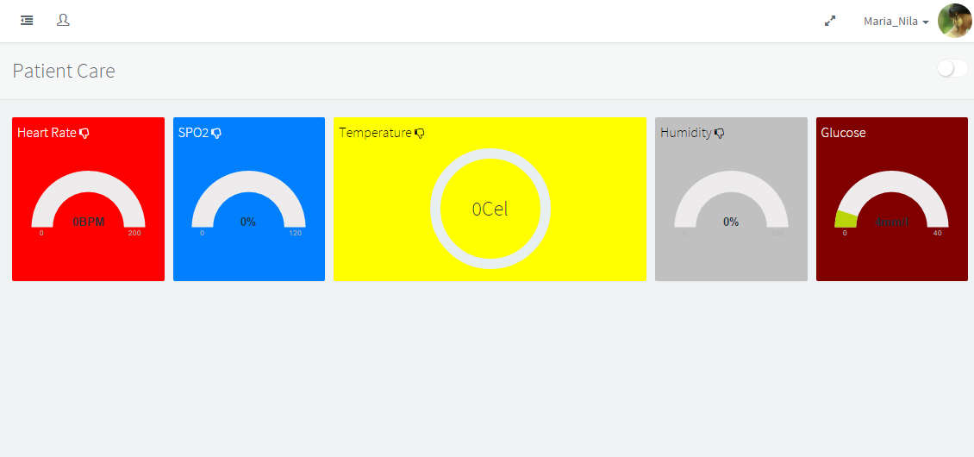

Figure 4-3: Web Interface

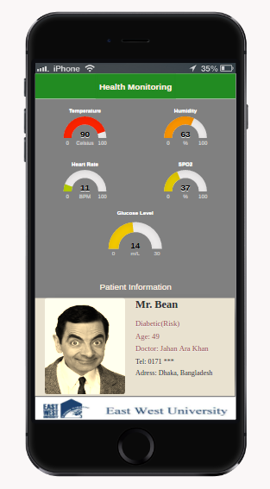

Figure 4‑4: Mobile Application

Figure 4-3 and Figure 4-4 explains the web interface and mobile application. In the Interface we can Interface we can see a real-time health monitoring for a patient. The display tells about Temperature, Sugar level, Moisture, Heart Rate and Oxygen Saturation.

## **IoT Platforms and Data Security**

These days, all Internet of Things stages out there are essentially servers to store data from gadgets. It is very regular to see "IoT stages" that are depending on a similar Web innovation utilized amid the most recent decade, however now to speak with the IoT gadgets. In this structure, the little gadgets simply push information to this sort of servers by simply doing customary and wasteful HTTP POST asks. Other minor options depend on utilizing more proficient conventions like CoAP, or MQTT, as they have been particularly intended for IoT, or M2M applications. In this way, fundamentally, the majority of the IoT stages has been considered simply like an information distribution center for the putting away and showing detected data from our condition. In the contrary way, the Thinger.io stage began as a stage for detecting and activating over gadgets continuously, something that is absent in numerous IoT stages. In our stage you can simply turn on and off things over a dashboard, a cell phone, or even from a smartwatch (progressively), or show diagrams plotting data immediately from the gadget. This innovation has incalculable advancements in the engine to limit information data transfer capacity, handling power, code size, or server adaptability, as all the biological community was completely composed sans preparation in present day C++, utilizing multithreaded ASIO for the server side, and not simply stock Web servers. Biomedical data are sensitive. We get it through from server in hospital. Confidential data are exchange with doctor and patient by internet.in this whole process if someone set up a false server and get this important information than security of data threatening position.in this situation we can use HTTPS protocol which is known as adjustment of the Hypertext Transfer Protocol (HTTP) for secure correspondence over a PC organize, and is generally utilized on the Internet In HTTPS, the correspondence convention is encoded by Transport Layer Security (TLS), or once in the past, its ancestor, Secure Sockets Layer (SSL). The convention is consequently likewise frequently alluded to as HTTP over TLS or HTTP over SSL

The main inspiration for HTTPS is validation of the got to site and insurance of the protection and trustworthiness of the traded information. It ensures against man-in-the-center assaults. The bidirectional encryption of correspondences between a customer and server ensures against listening in and altering of the communication. By and by, this gives a sensible confirmation that one is imparting without obstruction by aggressors with the site that one planned to speak with, rather than an impostor. The security of HTTPS is that of the hidden TLS, which regularly utilizes long haul open and private keys to produce a fleeting session key, which is then used to scramble the information stream amongst customer and server. X.509 testaments are utilized to validate the server (and now and then the customer too). As a result, endorsement specialists and open key testaments are important to confirm the connection between the declaration and its proprietor, and also to produce, sign, and direct the legitimacy of authentications. While this can be more useful than checking the personalities by means of a web of trust, the 2013 mass reconnaissance exposures attracted regard for endorsement specialists as a potential frail point permitting man-in-the-center attacks. An essential property in this setting is forward mystery, which guarantees that encoded correspondences recorded in the past can't be recovered and unscrambled should long haul mystery keys or passwords be traded off later. Not all web servers give forward secrecy.

A site must be totally facilitated over HTTPS, without having some portion of its substance stacked over HTTP – for instance, having contents stacked shakily – or the client will be powerless against a few assaults and observation. Likewise having just, a specific page that contains delicate data, (for example, a sign in page) of a site stacked over HTTPS, while having whatever is left of the site stacked over plain HTTP, will open the client to assaults. On a site that has touchy data some place on it, each time that site is gotten to with HTTP rather than HTTPS, the client and the session will get uncovered. Correspondingly, treats on a site served through HTTPS need to have the safe quality enabled.

# 

# 

# Chapter 5

***Conclusion***

## **Overall Conclusion**

In this process, we developed a hardware system for identifying blood pressure, glucose, humidity etc. for patient like heart, diabetes so on. All this information goes to the cloud through server, so a doctor can easily see a critically ill patient information. Our system is time efficient as it can identify three sensors at a time like Temperature, Oxygen Saturation, Heart rate at a time. Through our system a Doctor can monitor a patient bio status and for that a patient do not have to physically present. So, whenever a patient feels ill he/she can check his own bio status and communicate with the doctor immediately. At long last, we present IoT with all the above points discussed. Here everything is executed and actualized, all things considered, situation.in future our system will be worked with many places with many sensors. Initially we think it can be applied in city in future if it is applying with business idea to make it profitable than whole country can use it. To country like Bangladesh where medical services is not accessible or costly for many people this system is quite cost efficient for many family. For individual diseases patient don’t need to go to several doctors and misplace of their information cannot happen. As this system will give the benefits to doctors. Medical students, clinical company, people who work with IoT.

## **Future Work**

Our future work will include further improvements to the glucometer used in our experiment. We wish to add more actuators in our system so that It can take steps in case of any life-threatening condition. We will use machine learning in our so that it can detect false alarms and provide services according to the actual needs of patients. In future we also want to include different types of bio Sensors to monitor the patient bio status

* Electrocardiogram(ECG) sensor
* Electroencephalography(EEG) sensor

**Bibliography**

[1] Bhoomika.B.K, Dr. K N Muralidhara, “Secured Smart Healthcare Monitoring System Based on IOT”, IJARCSMS, ISSN: 2321-81 Volume: 3 Issue: 7 4958-4961 JULY 2015.

[2] Ms. Neeta V Desai, Saniya Ansari. “Review of Patient Monitoring System with Wireless” IJCSIT ISSN: 2277 128X Volume 5, Issue 1, January 2015

[3] Gennaro Tartarisco, Giovanni Baldus, Daniele Corda, Rossella Raso, Antonino Arnao, Marcello Ferro, Andrea Gaggioli, Giovanni Pioggia, “Personal Health System architecture for stress monitoring and support to clinical decisions”, Computer CommunicationsVol.35, pp.1296– 1305, 2012.

[4] Franca Delmastro, “Pervasive communications in healthcare”, Computer Communications Vol.35, pp.1284– 1295,2012. Aruna Devi.S et al. / International Journal of Computer Science & Engineering Technology (IJCSET) ISSN: 2229-3345 Vol. 7 No. 03 Mar 2016 72

[5] MiniMed 530G User Guide, Paradigm REAL-Time Revel System Insulin Pump User Guide

[6] Grunberger G, Bailey TS, Cohen AJ, et al; and AACE Insulin Pump Management Task Force. Statement by the American Association of Clinical Endocrinologists Consensus Panel on insulin pump management. Endocr Pract. 2010;16(4):746-762

[7] Jongyoon Choi, Beena Ahmed and Ricardo Gutierrez-Osuna, Development and valuation of an Ambulatory Stress Monitor Based on Wearable Sensors, IEEE transactions on information technology in biomedicine, vol. 16, no. 2, March 2012